A1_Problem2

library("gurobi")

## Loading required package: slam

library("Matrix")  
library("igraph")

##   
## Attaching package: 'igraph'

## The following objects are masked from 'package:stats':  
##   
## decompose, spectrum

## The following object is masked from 'package:base':  
##   
## union

library("rdist")  
  
L = 5  
K = 3  
  
coordinates.l = matrix(c(3,6,4,4,3,0,2,1,0,1), nrow=L, ncol=2, byrow = TRUE)  
coordinates.k = matrix(c(3,3,2,4,2,5), nrow=K, ncol=2, byrow = TRUE)  
coordinates.all = rbind(coordinates.l, coordinates.k)  
  
P.kl = cdist(coordinates.k, coordinates.l, metric = "euclidean", p = 2)  
  
plot(coordinates.all[,1], coordinates.all[,2], pch=16)

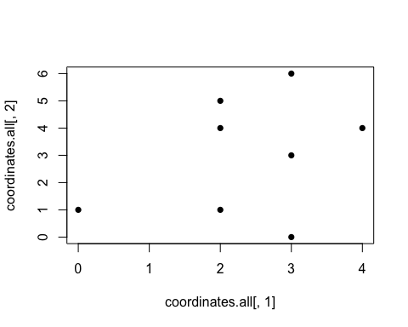

plot(coordinates.k[,1], coordinates.k[,2], pch=16)

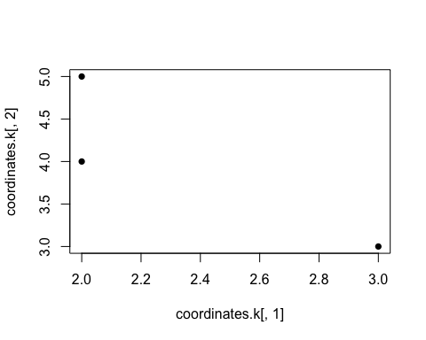

D.l = sample(c(20,40,15,30,25))  
cvec = c(as.vector(t(P.kl)))  
bvec = c(1,1,1,1,1)  
dir = c("=","=","=","=","=")  
  
Amat = matrix(0, nrow=(L), ncol=(L*K))  
Amat[1,] = c(1,0,0,0,0,1,0,0,0,0,1,0,0,0,0)  
Amat[2,] = c(0,1,0,0,0,0,1,0,0,0,0,1,0,0,0)  
Amat[3,] = c(0,0,1,0,0,0,0,1,0,0,0,0,1,0,0)  
Amat[4,] = c(0,0,0,1,0,0,0,0,1,0,0,0,0,1,0)  
Amat[5,] = c(0,0,0,0,1,0,0,0,0,1,0,0,0,0,1)  
  
image(Matrix(Amat))

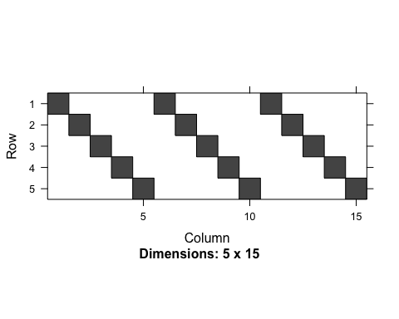

myLP = list()  
myLP$obj = cvec  
myLP$A = Amat  
myLP$sense = dir  
myLP$rhs = bvec  
myLP$vtypes = "C"  
myLP$ub = 1  
  
mysol = gurobi(myLP)

## Warning for adding variables: zero or small (< 1e-13) coefficients, ignored  
## Optimize a model with 5 rows, 15 columns and 15 nonzeros  
## Coefficient statistics:  
## Matrix range [1e+00, 1e+00]  
## Objective range [1e+00, 5e+00]  
## Bounds range [1e+00, 1e+00]  
## RHS range [1e+00, 1e+00]  
## Presolve removed 5 rows and 15 columns  
## Presolve time: 0.01s  
## Presolve: All rows and columns removed  
## Iteration Objective Primal Inf. Dual Inf. Time  
## 0 1.1670046e+01 0.000000e+00 0.000000e+00 0s  
##   
## Solved in 0 iterations and 0.01 seconds  
## Optimal objective 1.167004638e+01

mysol$objval

## [1] 11.67005

mysol$x

## [1] 0 1 1 1 0 0 0 0 0 1 1 0 0 0 0